武汉大学计算机学院
本科生课程设计报告

Design and Implementation of the Gobang Chess Game

专 业 名 称 ：软件工程
课 程 名 称 ：Windows原理与应用
指 导 教 师 一：孔若杉 副教授
指 导 教 师 二：
学 生 学 号 ：2021326660023
学 生 姓 名 ：Chaiwat Plongkaew

二○二一年十二月

郑 重 声 明

本人呈交的设计报告，是在指导老师的指导下，独立进行实验工作所取得的成果，所有数据、图片资料真实可靠。尽我所知，除文中已经注明引用的内容外，本设计报告不包含他人享有著作权的内容。对本设计报告做出贡献的其他个人和集体，均已在文中以明确的方式标明。本设计报告的知识产权归属于培养单位。

本人签名： Chaiwat Plongkaew 日期： 23/11/2023

Abstract

The aims and objectives of this experiment are to develop a Gobang game software system using Visual Studio and C++ programming language. I also Utilized the MFC (Microsoft Foundation Classes) library for creating the graphical user interface (GUI) of the game.
A Gobang chess game is developed. The main features include providing a playable game board/grid, allowing two players to take turns making moves, validating and enforcing the game rules, such as checking for winning conditions, displaying the game status, including the current player’s turn, allowing players to save, load, start a new game or exit the application, and providing options for customizing game settings, the board size, player’s turn, and background color.
The system functions properly. All the requirements are met.
Table of Contents
1. Experiment 1
1.1 Gobang version 1st ………………………………………………………………………4
1.2 Drawing the Chessboard ………………………………………………………………4
1.3 Drawing the Pieces………………………………………………………………………5
1.4 Check Winning Condition………………………………………………………………6

2. Experiment 2
2.1 Gobang Version 2nd……………………………………………………………11
2.2 OnFileNewgame…………………………………………………………………11
2.3 OnFileLargechessboard and OnFileLargechessboard……………………12
2.4 Undo and Redo…………………………………………………………………13
2.5 File Option and Option Dialog……………………………………………14

3. Experiment 3
3.1 Gobang version 3rd ……………………………………………………………18
3.2 View part………………………………………………………………………18
3.3 Document part…………………………………………………………………19
3.4 OnNewDocument…………………………………………………………………20
3.5 Serialization…………………………………………………………………20
3.6 Toolbar…………………………………………………………………………22
3.7 Status bar………………………………………………………………………24

Conclusion …………………………………………………………………………… 25
References …………………………………………………………………………… 27
1. Experiment 1

1.1 Gobang version 1st
In this experiment, the implementation of functions of the game including drawing the chessboard, drawing the chess, and checking the winning condition are all in the mainfrm.cpp. In addition, the variables of the game also contain in the mainfrm.cpp.
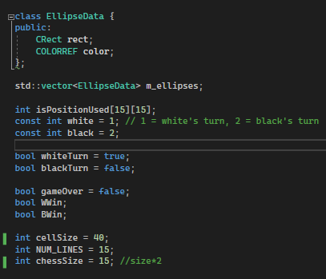

1.2 Drawing the Chessboard
To generate the chessboard, I utilize the OnPaint() function, which is responsible for rendering all elements of our game onto the window. Before adding the drawing logic to the function, it is essential to initialize the device context to obtain the client area required for drawing. Then, I use dc.FillSolidRect() and dc.SetViewportOrg() to set the green background color and the margin of the board which is according to the cellSize(40 pixels). You can see Figure 1.1 below.
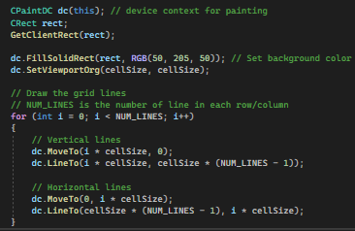
Figure 1.1

After obtaining the device context, I can proceed to draw the chessboard using a for-loop as illustrated in Figure 1.1. By utilizing the dc.MoveTo() and dc.LineTo() functions, we can create lines connecting the starting and ending points. Our objective is to draw a total of 15 vertical and 15 horizontal lines, with the gap between each line being set to the cellSize. The result is as you can see below.
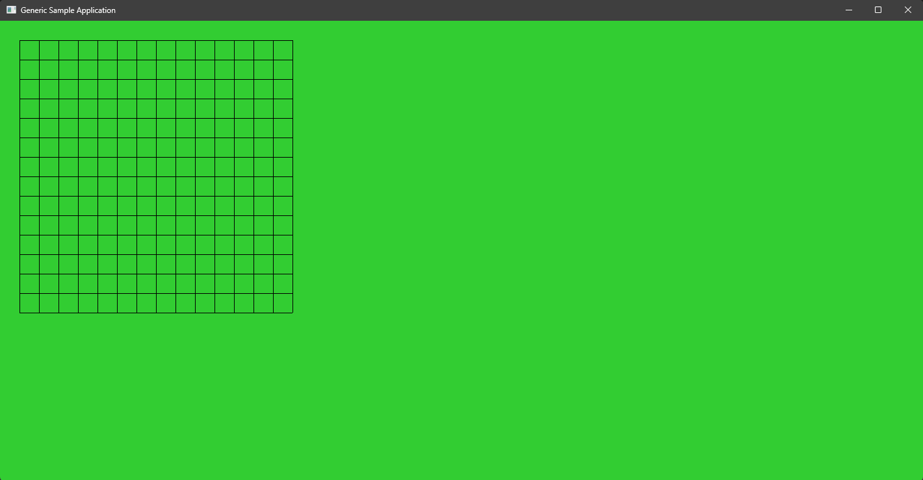

1.3 Drawing the Pieces
To allow players to click on the board for placing the chess, we need to use OnLButtonDown(). This function can receive the coordinates of the player’s clicking.
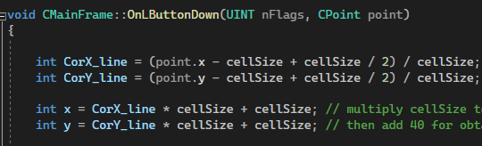

CorX_line and CorY_line are used to record which lines that the piece is placed. x and y represent the pixel coordinates where the ellipse will be drawn on the frame window.

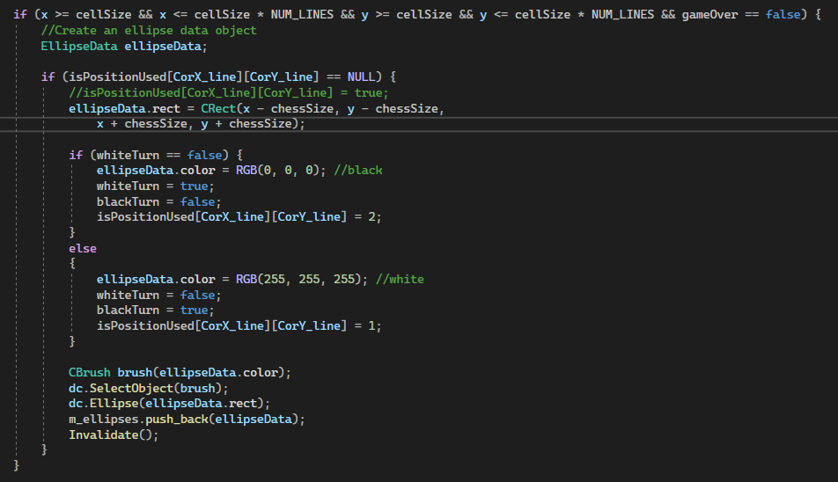

In the first condition, if the pixel coordinates (x and y) fall within the valid range on the game grid, and if the game is not already over. If these conditions are met, the code proceeds to create an ellipse data object (EllipseData) to represent a player's move.
Next, it checks if the clicked grid position (CorX_line and CorY_line) is not already occupied (isPositionUsed[CorX_line][CorY_line] == NULL). If the position is available, the code sets the properties of the ellipse data object. It defines the rectangle coordinates (ellipseData.rect) for drawing the ellipse on the frame window based on the pixel position (x and y) and the size of the chess piece (chessSize).
The code then determines the color of the ellipse based on the current player's turn. If it's not the white player's turn (whiteTurn == false), the color is set to black (RGB(0, 0, 0)), and the turn variables are updated accordingly. If it's the white player's turn, the color is set to white (RGB(255, 255, 255)) and the turn variables are updated.
After setting up the EllipseData object, it adds the object to a collection (m_ellipses) for later reference. Then, the Invalidate() function is called to indicate that the frame window's client area needs to be repainted.
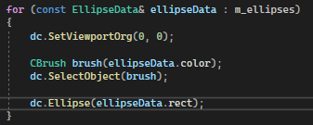

After the function called invalidated, the OnPaint() will redraw everything again. In the last for-loop, it iterates over each EllipseData object stored in the m_ellipses collection. The loop variable ellipseData represents the current EllipseData object in each iteration.
Inside the loop, the viewport origin of the device context is temporarily set to (0, 0) using dc.SetViewportOrg(0, 0). This ensures that the subsequent drawing operations are performed relative to the top-left corner of the client area.
A CBrush object is created using the color (ellipseData.color) specified in the current EllipseData. The CBrush object is then selected into the device context using dc.SelectObject(brush). This sets the brush as the current brush for filling shapes.
Finally, the ellipse is drawn on the device context using the dc.Ellipse(ellipseData.rect) call. The coordinates for drawing the ellipse are specified by the rect property of the current EllipseData, which represents the bounding rectangle of the ellipse.
1.4 Check Winning Condition
IsWinningMove()is responsible for checking whether a given move at a specific row and column position on the game board results in a winning condition. The function checks for winning patterns in vertical, horizontal, and diagonal directions.
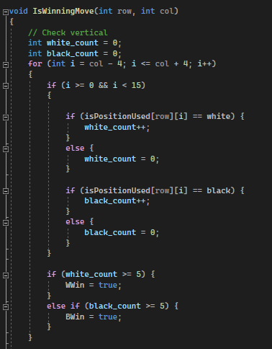

First, the code initializes counters for white pieces (white_count) and black pieces (black_count) to zero. Then, it proceeds to check for a vertical winning pattern by iterating from four positions before the current column (col - 4) to four positions after the current column (col + 4). Within this range, it checks if the position is within the game board boundaries (between 0 and 14). If it is, it increments the respective counter (white_count or black_count) based on the piece present at that position (isPositionUsed[row][i]). If the counter reaches or exceeds five, it sets the corresponding winning flag (WWin or BWin) to true.
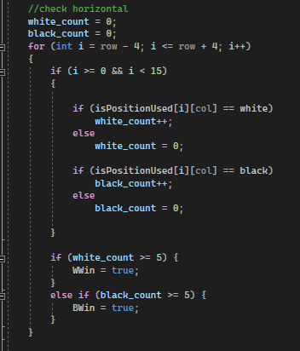

Next, the code performs a similar check for a horizontal winning pattern by iterating from four positions before the current row (row - 4) to four positions after the current row (row + 4). It checks the position's validity, increments the counters accordingly, and updates the winning flags if necessary.
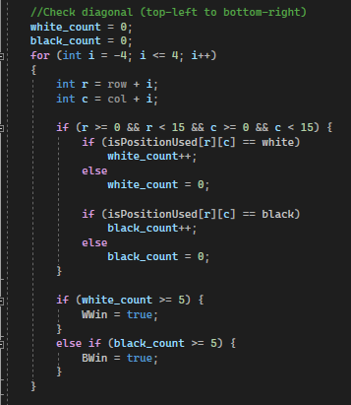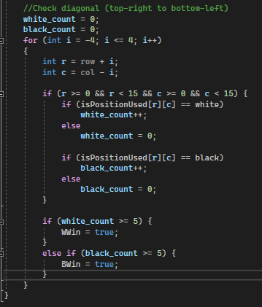

The code then checks for diagonal winning patterns in two directions. First, it checks the diagonal from the top-left to the bottom-right by iterating from -4 to 4 and calculating the corresponding row (r) and column (c) positions based on the initial row and column. It checks the validity of the position, updates the counters, and sets the winning flags if applicable. Finally, the code checks the diagonal from the top-right to the bottom-left using a similar process as the previous diagonal check.

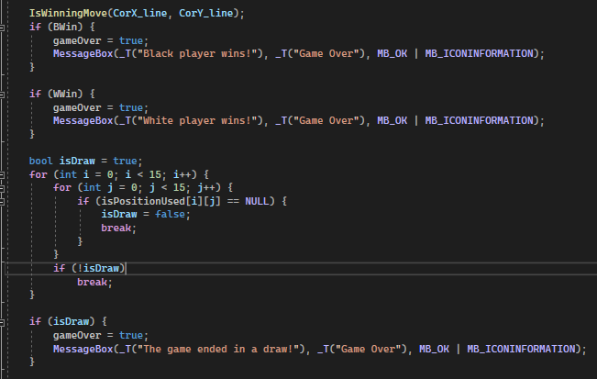

Let’s come back to the OnLButtonDown(), after the code invalidates the OnPaint(), the code calls the IsWinningMove function with the current move's row and column (CorX_line and CorY_line). This function checks for winning conditions and updates the BWin and WWin flags accordingly.
Next, it checks if the black player has won (BWin). If so, it sets the gameOver flag to true, indicating that the game has ended, and displays a message box to announce the victory of the black player.
Similarly, it checks if the white player has won (WWin). If true, it sets the gameOver flag to true, displays a message box to announce the victory of the white player, and ends the game.
After that, the code checks for a draw by iterating over the isPositionUsed array. If any position is still unoccupied (NULL), the isDraw flag is set to false. If all positions are occupied, the isDraw flag remains true.
If a draw is detected (isDraw == true), it sets the gameOver flag to true, displays a message box indicating the draw, and ends the game.

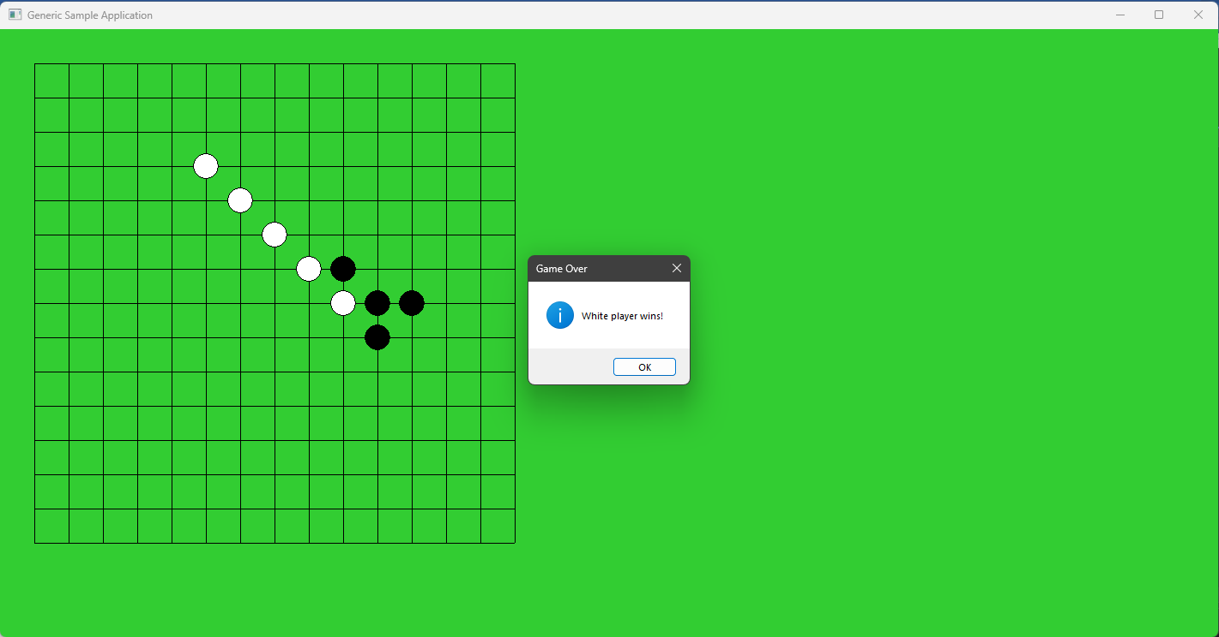

2. Experiment 2
2.1 Gobang Version 2nd
In this version, I have restructured the file by transferring all the event handlers to the CChildview.cpp, and added a menu that contains the following items:
- File: New Game, Option, Exit
- Edit: Undo, Redo
For the Option menu item, I added an Option dialog box which contains the chessboard color configuration and the first player selection.

2.2 OnFileNewgame
This function is a command handler for creating a new game. It performs several actions to reset the game state and prepare for a fresh game.
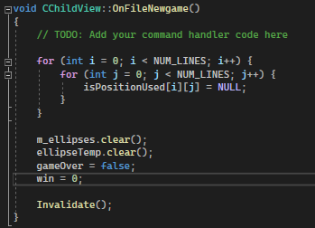

The nested for loops iterate over each position on the game grid, represented by the isPositionUsed array. For each position, the value is set to NULL, indicating that it is unoccupied. The m_ellipses vector is cleared using the clear() function. This removes all previously drawn ellipses from the vector. Next, the ellipseTemp vector is also cleared. This vector serves as a temporary storage for ellipses during the game, which is used for redo and undo functions. Before calling invalidate, the gameOver and win are set to false and 0, indicating that the game is not yet.
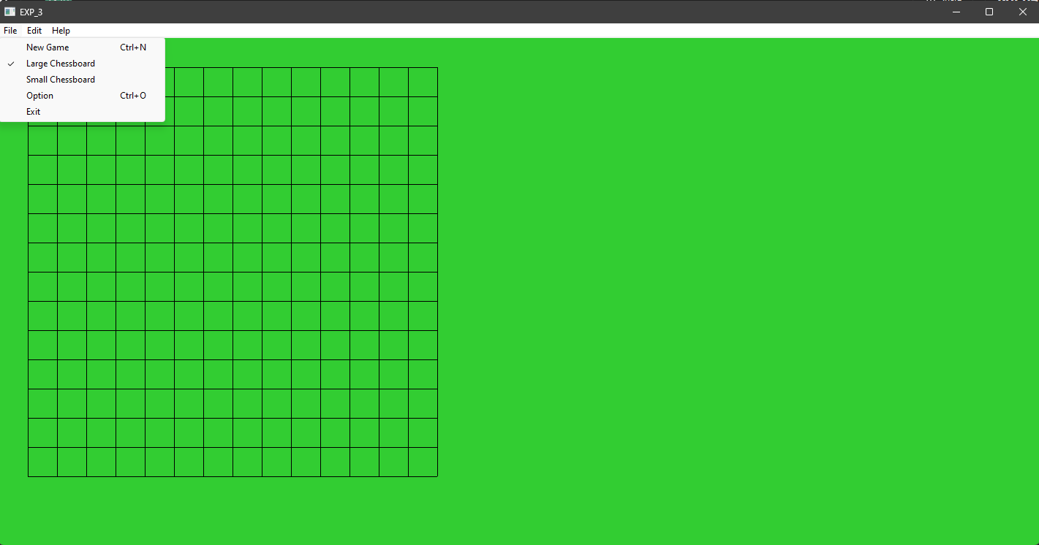

2.3 OnFileLargechessboard and OnFileLargechessboard
Both Functions are command handlers for allowing the user to change the size of the chessboard in the game, updating the positions and sizes of the ellipses representing the game moves, and refreshing the display to reflect the changes made.
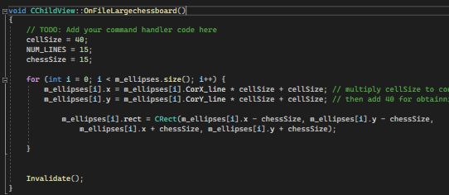

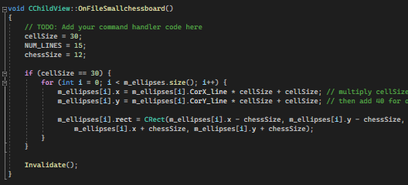

In OnFileLargechessboard(), the cellSize variable is set to 40, indicating that each cell on the chessboard will be 40 pixels in size. The NUM_LINES variable is set to 15, representing the number of lines (rows and columns) on the chessboard. The chessSize variable is set to 15, determining the size of the chess pieces.
The function then loops over each EllipseData object in the m_ellipses vector. It updates the x and y coordinates of each ellipse by multiplying the current CorX_line and CorY_line values by the cellSize and adding cellSize to obtain the final pixel position after removing the initial offset. The rect property of each EllipseData is also updated to create a bounding rectangle for the ellipse, using the updated coordinates and the chessSize variable. Finally, Invalidate() is called to invalidate the window and trigger a redraw to reflect the changes.

In OnFileSmallchessboard(), the function follows a similar structure with a few differences. The cellSize is set to 30, indicating a smaller pixel size for each cell on the chessboard. The chessSize is set to 12, representing a smaller size for the chess pieces. The loop inside the function is executed only if cellSize is equal to 30, indicating that the small chessboard is already selected.
Inside the loop, the x and y coordinates of each ellipse are updated based on the CorX_line, CorY_line, and cellSize values. The rect property of each EllipseData is updated accordingly. Finally, Invalidate() is called to trigger a redraw.

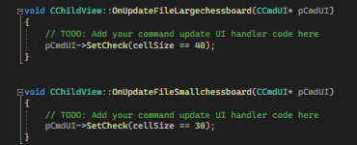

These functions above ensure that the user interface accurately reflects the current chessboard size in the application. By checking the value of the cellSize variable, the functions determine whether the large chessboard size (40) or small chessboard size (30) is currently selected. If the cellSize matches the respective size, the SetCheck() function is called on the pCmdUI object to enable the check mark for the corresponding option in the user interface. This visual indication allows users to easily identify which chessboard size is currently active in the application.

2.4 Undo and Redo
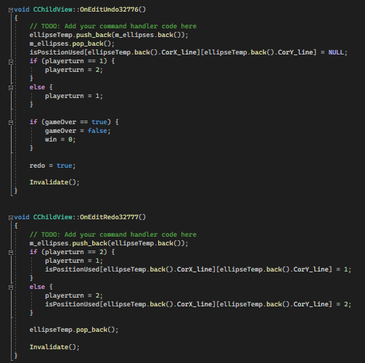

The Undo function is triggered when the user selects the "Undo" action. Inside this function, several actions are performed. First, it saves the last ellipse from the m_ellipses vector into another vector called ellipseTemp. Then, it removes the last ellipse from m_ellipses. Next, it updates a two-dimensional array called isPositionUsed to indicate that the position previously occupied by the removed ellipse is now available. The function also handles the logic related to player turns, switching the turn from player 1(White) to player 2(Black) or vice versa. If the game is over, it resets the necessary flags and variables. Finally, it sets a boolean variable redo to true and requests a redraw of the view.

The Redo function is the counterpart to the "Undo" action and is triggered when the user selects the "Redo" action. When this occurs, the function retrieves the last ellipse from the ellipseTemp vector and adds it back to the m_ellipses vector. It updates the isPositionUsed array to reflect the occupied position based on the playerturn variable. It then removes the last ellipse from ellipseTemp and requests a redraw of the view.

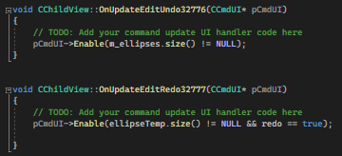

The OnUpdateEditUndo32776() and OnUpdateEditRedo32777() functions handle the enabling or disabling of the "Undo" and "Redo" menu items or toolbar buttons. They check the sizes of the m_ellipses and ellipseTemp vectors, as well as the value of the redo variable, to determine whether the UI elements should be enabled or disabled based on the current state of the application.

2.5 File Option and Option Dialog
The "File Option" command displays a dialog box (OptionDialog) that allows the user to select color and radio button options. The selected options are then applied to the relevant variables and used to update the display.

Creation of OptionDialog
The OptionDialog class is derived from the CDialog class, which is the base class for dialog boxes in MFC. The constructor initializes the dialog box by calling the CDialog constructor and setting the resource ID for the dialog box.
The DoDataExchange function is overridden to handle data exchange between the dialog box controls and member variables. In this case, the COLORLIST control, which is a drop-down list, is associated with the COLORLIST member variable. Additionally, the radio button choice is associated with the rd member variable.
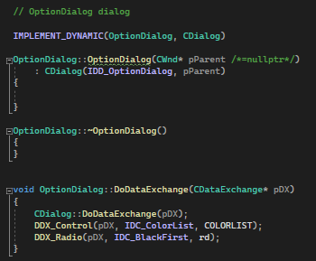

During initialization, the OnInitDialog function is called. It populates the COLORLIST control with several color options by adding strings representing the color names. Corresponding RGB values are associated with each color using the SetItemData function. The function also sets the currently selected color in the COLORLIST control based on the value stored in the selectedColorIndex variable.
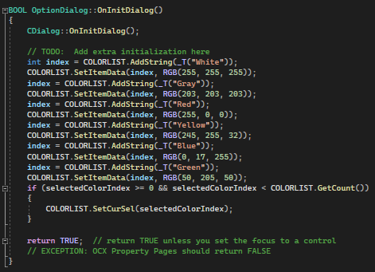

When the OK button is clicked, the OnBnClickedOk function is called. It retrieves the selected color index from the COLORLIST control using GetCurSel. If a valid index is obtained, it retrieves the associated RGB value using GetItemData. The selected color and index are stored in the selectedColor and selectedColorIndex member variables, respectively.
Finally, the OnOK function is called to close the dialog box and return control to the calling code.
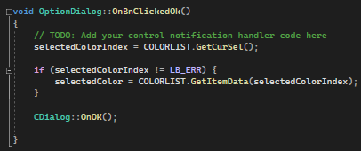

OnFileOption()
Firstly, the OptionDialog instance dlg is created. This dialog box will be used to present the available options to the user. The rd member variable of dlg is then set to 0 and the selectedColorIndex member variable is set to 2. These values represent pre-defined options for colorNext and currentbg, respectively. This ensures that the selected option is pre-set in the dialog box. Additionally, the selectedColorIndex member variable of dlg is assigned the value of the currentbg variable, representing the currently selected background color index.
Next, the DoModal() function is called on the dlg object, which displays the dialog box and waits for user input. If the user clicks the OK button, indicating that they have made their selection, the code within the if statement is executed.
Within the if statement, the selected options are retrieved from the dlg object and assigned to the corresponding variables. The colorNext variable is updated with the value of rd, representing the selected radio button choice. The currentbg variable is updated with the value of selectedColorIndex, representing the selected background color index. Additionally, the bgColor variable is assigned the value of selectedColor, which represents the selected background color.
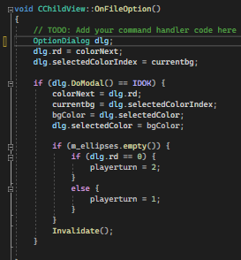

If the m_ellipses vector is empty, meaning there are no existing ellipses in the view, the playerturn variable is updated based on the selected radio button choice (rd). If rd is 0, indicating the "Black First" option is selected, playerturn is set to 2. Otherwise, if rd is 1, indicating the "White First" option is selected, playerturn is set to 1.
Finally, the Invalidate() function is called, which triggers a redraw of the view. This ensures that the display is updated with the newly selected options, reflecting any changes made by the user in the dialog box.

3. Experiment 3
3.1 Gobang version 3rd
In this final version, I have made significant updates to the game, focusing on the division of responsibilities between the document and view parts in the document/view architecture.

In the document part, I have incorporated functions for storing and opening game data. By transferring important game information to the document, such as the state of the game board and player turns, I ensure that the data is properly managed and persisted. This allows users to save their progress and resume the game at a later time. By integrating these functions into the file menu, users can easily access and manipulate game files, enhancing the usability and convenience of the game.

On the other hand, in the view part, I have leveraged the drawing functionality. By inheriting from CScrollView, I have incorporated scroll bars into the game interface. This enables users to navigate and view larger game boards or content that extends beyond the visible window area. The view part is responsible for rendering the game board, chess pieces, and any other visual elements. Additionally, I have handled mouse clicking events in the view part, allowing users to interact with the game board and make moves by clicking on the desired grid cells.

To provide a more user-friendly experience, I have added a toolbar to the game interface. The toolbar includes several buttons that are synchronized with corresponding menu items, enabling users to perform common actions directly from the toolbar. This enhances the accessibility and efficiency of the game.

Furthermore, I have incorporated a status bar with two panes. The first pane displays flyby text, which can provide contextual information or interactive hints to the user. The second pane indicates the next player, keeping users informed about the game's progress and upcoming moves. By updating the status bar dynamically based on the player turns, users have a clear indication of which color's turn is next.

3.2 View part
CScrollView is a derived class of CView and provides additional functionality specifically designed for handling scrolling within the view. By using CScrollView, the game interface can accommodate larger game boards or content that extends beyond the visible window area.
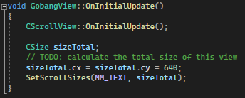

In the code above, the CSize variable called sizeTotal is declared. This variable will be used to determine the total size of the view.
To calculate the total size of the view, the code sets both the cx and cy members of sizeTotal to 640. This means that the view will have a width and height of 640 pixels. Then, the SetScrollSizes() function is called to set the scroll sizes for the view. The first parameter, MM_TEXT, specifies the mapping mode to be used for the scroll sizes. In this case, MM_TEXT indicates that the scroll sizes will be specified in logical units (pixels). The second parameter, sizeTotal, provides the calculated total size of the view.

3.3 Document part

In the Document file, we do not only transfer the data to it but also provide set and get functions for the view to manipulate the data that is inside the document file. Additionally, the document handles menu events within the application.
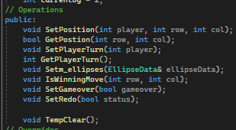

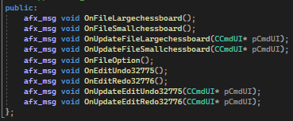

3.4 OnNewDocument

This function similar to OnFileNewgame in the second version. It is responsible for resetting the document's state and preparing it for a new game when a new document is created or opened in the application. The reason that this function had been used because it help document to validate the view. I have added the new variables which are playerturn(Black) and colorNext(White). In the if condition, the function first calls the base class's OnNewDocument() function to perform standard initialization. If this base class function returns FALSE, indicating a failure in creating the new document, the OnNewDocument() function also returns FALSE to indicate the failure.

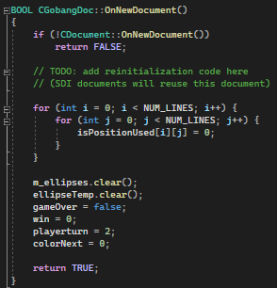

Because this function is related to the menu file, I need to explain a little modification of other events in the menu. To invalidate the drawing, UpdateAllViews has been called instead of using Invalidate. Invalidate function is typically called from the view class which document class unable to call this function directly. By using UpdateAllViews, it will internally call Invalidate on each associated view.

3.5 Serialization
Serialization is the process of converting an object's data into a format that is easily stored or transmitted, and then reconstructing the object from that format when needed.
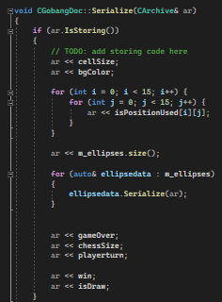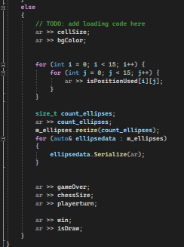
The Serialize() function is responsible for serializing the document's data to or from an archive (CArchive). This function is called when the document needs to be saved to a file or loaded from a file.
When the function is called with a storing archive (ar IsStoring()), it records the data of the document into the archive. It starts by writing the cellSize and bgColor variables to the archive. Then, it uses nested loops to iterate over the isPositionUsed 2D array and writes each element to the archive. Next, it writes the size of the m_ellipses vector to the archive and loops over each ellipsedata object in the vector. For each object, it calls the Serialize() function to write its data to the archive. Finally, it writes the gameOver, chessSize, playerturn, win, and isDraw variables to the archive.
Similarly, the loading process begins by reading the relevant data from the archive, such as cellSize, bgColor, isPositionUsed, m_ellipses, gameOver, chessSize, playerturn, win, and isDraw. It reads these values one by one from the archive and assigns them to the corresponding variables in the CGobangDoc object. By performing this loading process, the Serialize() function allows the object to be reconstructed with the same state it had when it was serialized and stored. This is useful when loading a previously saved document or when receiving serialized data from another source, as it ensures the object's state is accurately restored.

Serialization of Custom Class
For the EllipseData class, implementing the Serialize() function and declaring the class as derived from CObject with the DECLARE_SERIAL macro is required. The Serialize() function is responsible for handling the serialization process.

To enable serialization of the EllipseData class, the Serialize() function is used to write the object's data to an archive during storage and read the data from the archive during loading. In the Serialize() function, the base class implementation of Serialize() is called first, using CObject::Serialize(ar), to handle the basic serialization operations.
If needed, a copy constructor can be implemented to create a copy of an existing EllipseData object. The copy constructor ensures that the new object has the same state and properties as the original object.
By implementing the Serialize() function and the copy constructor, the EllipseData class becomes serializable. This allows instances of the class to be saved to a file or transmitted over a network, while preserving and restoring their state when needed.
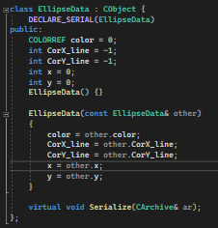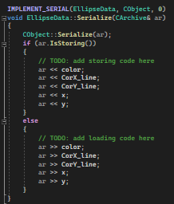

3.6 Toolbar
A toolbar is a graphical user interface (GUI) element that typically consists of a row or column of buttons or icons. The primary purpose of a toolbar is to provide quick and easy access to various features or actions within an application. By placing commonly used commands or tools in a toolbar, users can perform tasks with just a single click, eliminating the need to navigate through menus or search for specific functionality.

To create an icon in a toolbar, Resource Editor is the first choice, it allows us to visually design and manage resources without the need for extensive coding knowledge.

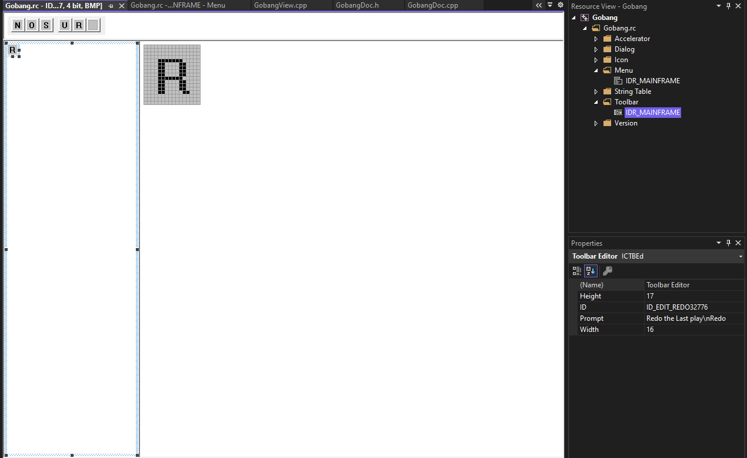
In Properties -> Toolbar Editor on the leftside, We can specify the Unique ID for the button, height, width, and tooltips.
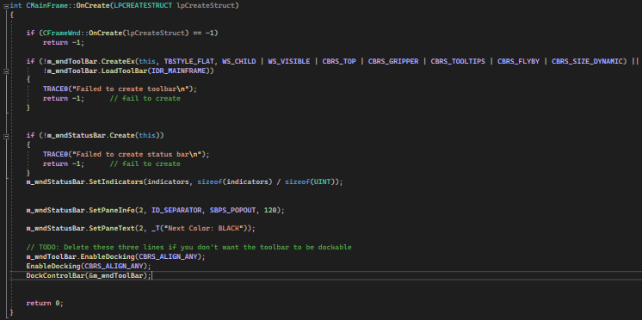

The OnCreate function is called first to perform the default creation of the frame window. If it returns -1, indicating an error, the function returns -1 to indicate the failure in creating the window.

Next, a toolbar (m_wndToolBar) is created and configured. The CreateEx function is used to create the toolbar with a specific style (TBSTYLE_FLAT). The toolbar is set to be a child window (WS_CHILD) and visible (WS_VISIBLE). It is positioned at the top of the frame window (CBRS_TOP). Additional styles such as gripper, tooltips, flyby, and dynamic size are also specified. If the toolbar creation or loading fails, an error message is printed, and -1 is returned to indicate the failure.

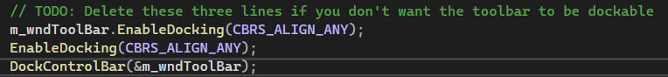
These lines of code, enable docking for the toolbar and the main frame window, allowing the toolbar to be docked to different positions within the frame. Finally, the toolbar is docked using the DockControlBar function.

3.7 Status bar
Following on from the Toolbar section, the creation of a status bar (m_wndStatusBar) is accomplished through the utilization of the Create function. If there is an error during the creation process, an error message will be shown and a return value of -1 will be supplied. The SetIndicators function is used to establish the status bar indicators, which specify the quantity and nature of the panes within the status bar. Additionally, the SetPaneInfo function is invoked to alter the properties of a particular pane within the status bar. In the current code, the second pane (indexed as 2) is adjusted to display a pop-out border (SBPS_POPOUT) and have a width of 120 pixels. Furthermore, the SetPaneText function is utilized to assign the text "Next Color: BLACK" to the second pane, which is intended for initial initialization purposes.

To enhance the interaction between the status bar and players' actions, I have made adjustments to two functions, namely OnLButtonDown and OnFileOption. Through these modifications, the status bar will be able to provide updated information regarding the next player who will participate in the upcoming round.

In the OnLButtonDown function, a pointer to the main frame window (CMainFrame) is obtained using AfxGetApp()->m_pMainWnd. This allows access to the status bar control. Subsequently, a pointer to the status bar (CStatusBar) is acquired from the main frame window. The code then checks the current player's turn by utilizing GetPlayerTurn() from the document. If the turn belongs to player 2 (black), the color of the chess piece is set to black (RGB(0, 0, 0)). The player turn is updated to 1 (indicating the next turn will be for the white player) using SetPlayerTurn(). Additionally, the position of the chess piece is set in the document through SetPosition(). To provide user feedback, the status bar text is updated using SetPaneText(), indicating that the next color to move is white.

On the other hand, if it is not player 2's turn (implying it is player 1's turn), the color of the chess piece is set to white (RGB(255, 255, 255)). The player turn is updated to 2 (indicating the next turn will be for the black player), and the position of the chess piece is updated in the document. The status bar text is modified accordingly to indicate that the next color to move is black.
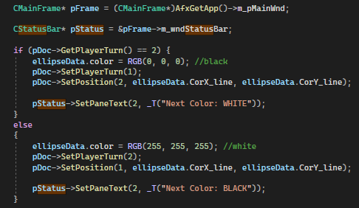

In the OnFileOption function, I have modified the code based on the selected color in the Option Dialog. If the user selected black as the next color, the "playerturn" variable is set to 2, indicating it's black's turn. The status bar text is then updated to display "Next Color: BLACK". Conversely, if the user selected white as the next color, the "playerturn" variable is set to 1 for white's turn, and the status bar text is updated to display "Next Color: WHITE".

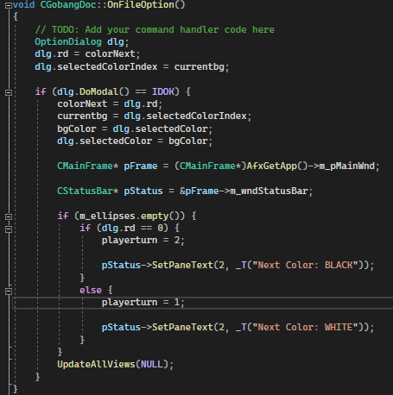

Conclusion
The development journey from the first version to the last version of the Gobang game has been enlightening and challenging. Several difficulties were encountered and lessons were learned along the way. Two notable challenges were the implementation of save and load functionality and the integration of the option dialog. Let's explore what was learned and the struggles faced during the implementation of these features.
The save and load functionality presented a significant challenge due to modifications made to the captions of IDR_mainframe in the string table. These modifications unknowingly caused the save and load operations to produce unexpected behavior.
Modifying the captions in the string table without considering how it will affect the save and load operations can lead to problems with the integrity of the game data. These captions are crucial for identifying and preserving the game state during these operations. If the modified captions do not fit with the expected data structure or format, inconsistencies and strange behaviors can occur. To address this, it is important to carefully review any modifications and make necessary adjustments to ensure that the save and load functionality works correctly.
The integration of the option dialog was a major challenge due to the presence of unnecessary variables, which caused confusion and complexity. Streamlining the code by analyzing the requirements and eliminating unnecessary variables while focusing on essential settings helped to reduce complexity and make the implementation more manageable.
Throughout the journey from the first to the last version of the Gobang game, valuable skills were acquired and obstacles were overcome. The implementation of save and load functionality expanded knowledge in file I/O operations and serialization techniques, while the integration of the option dialog enhanced skills in dialog controls, event handling, and user interface design. Overcoming the difficulties encountered during the implementation of these features required diligent debugging, creative problem-solving, and a deep understanding of programming concepts.

References
[1] Programming Windows with MFC, Second Edition, 1999
[2] MFC - Dialog Boxes: https://www.tutorialspoint.com/mfc/mfc_dialog_boxes.htm
[3] Serialization: Making a Serializable Class, 2021: https://learn.microsoft.com/en-us/cpp/mfc/serialization-making-a-serializable-class?view=msvc-170

